Matrix Multiplication

Input – M matrix 2X2 identity matrix

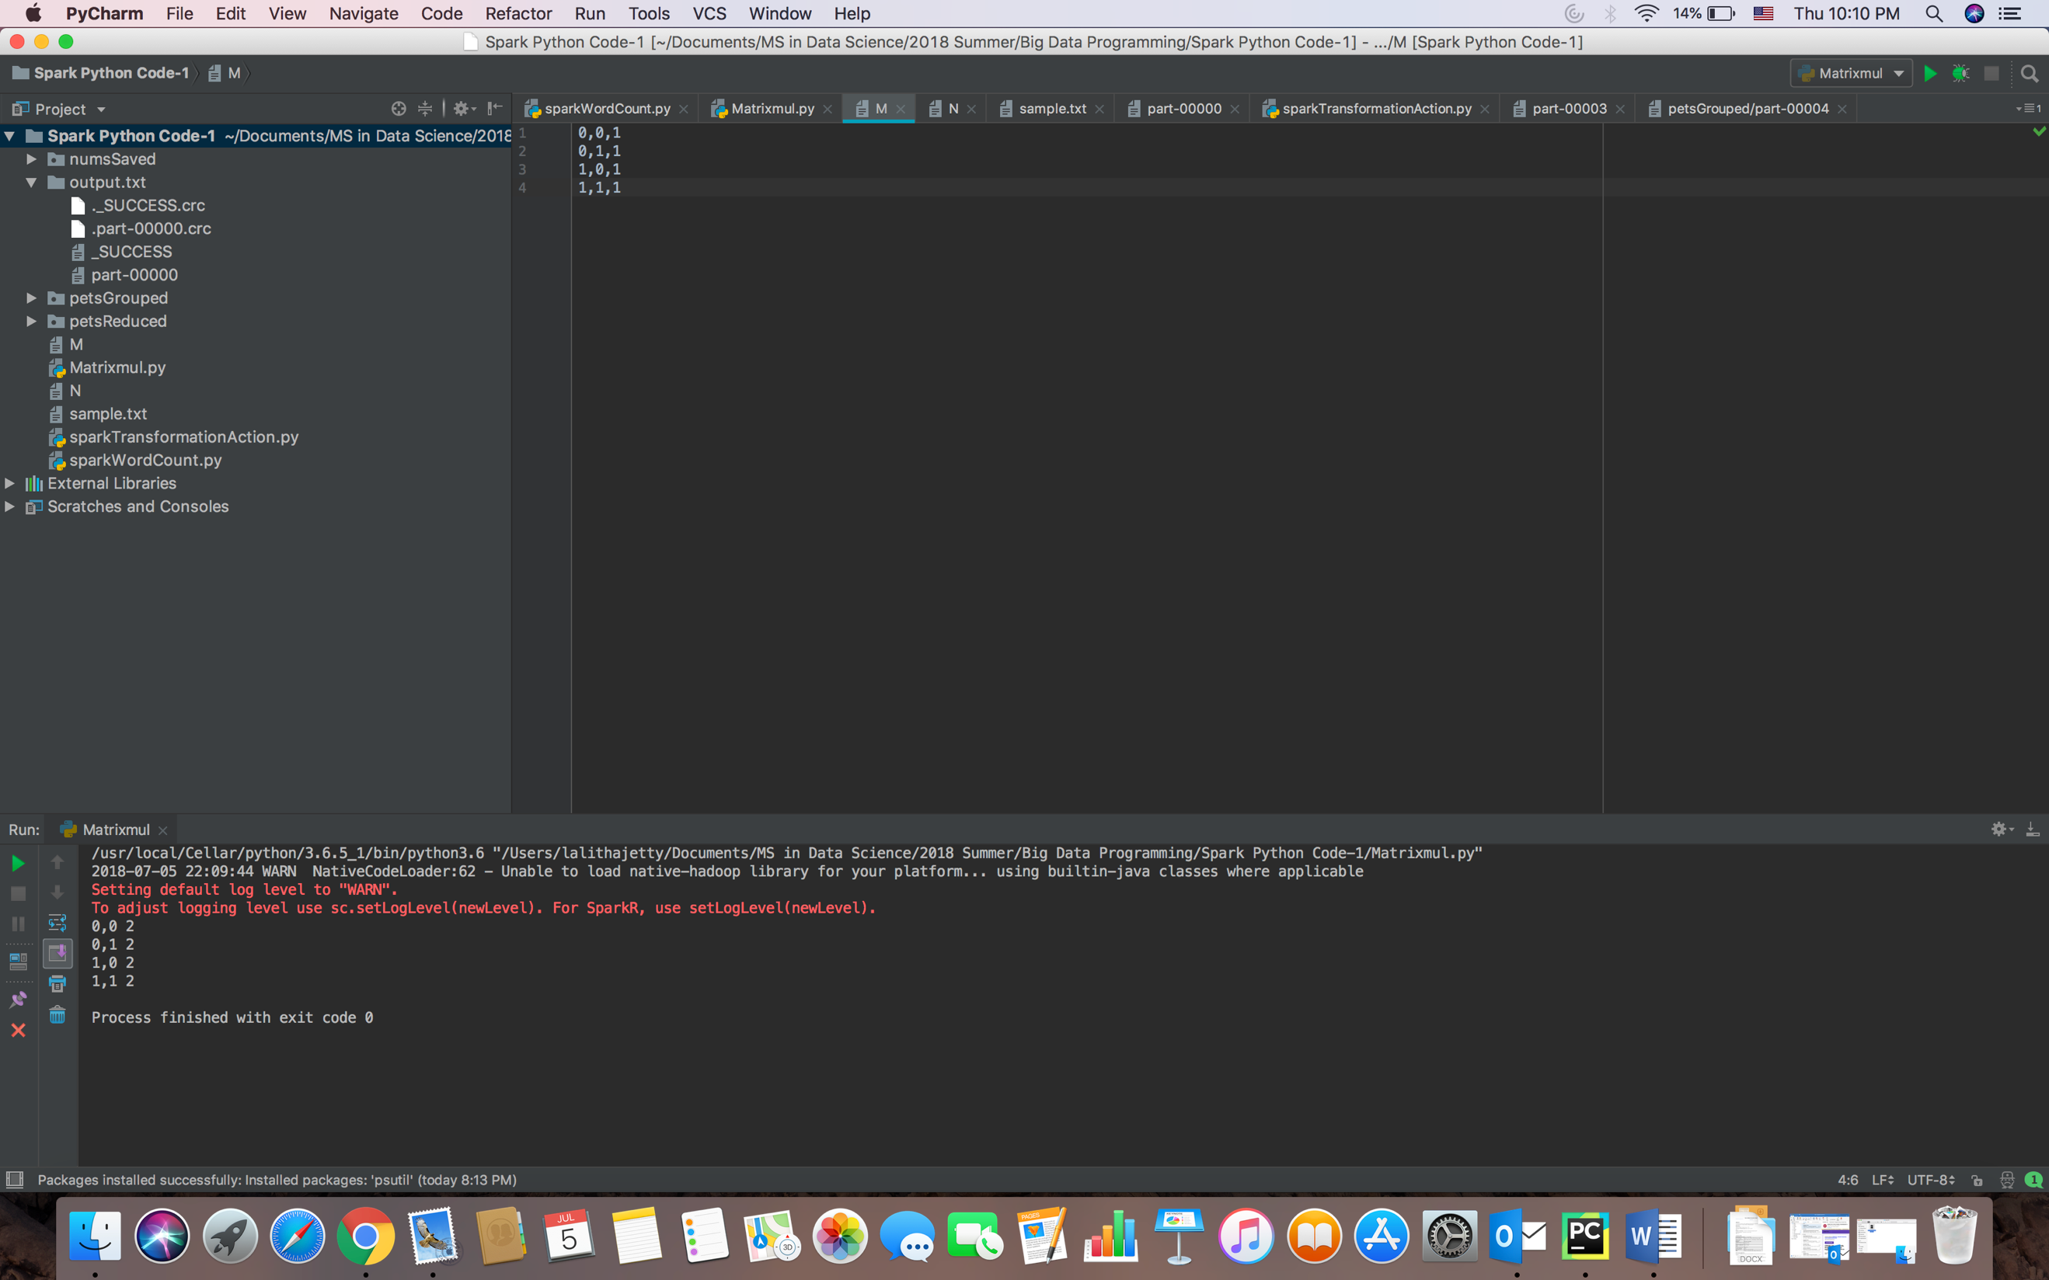

Input – N matrix 2X2 identity matrix

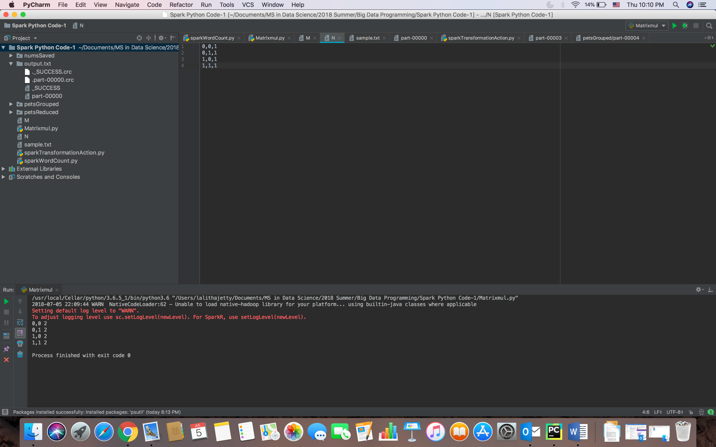

Output: 2X2 matrix with all the elements 2

